Requirement analysis PHASE-I
Data Flow Diagram & User Stories
Date | 19 September 2026
Team ID | SWTID-2026-6039
Project Name | AI WeatherWise API
Maximum Marks | 4 Marks

1. Data Flow Diagrams:
A Data Flow Diagram (DFD) represents how information enters, moves through, is processed by, and is stored within the AI WeatherWise system. The following Level 0 DFD is prepared for the WeatherWise API and its main user functions.

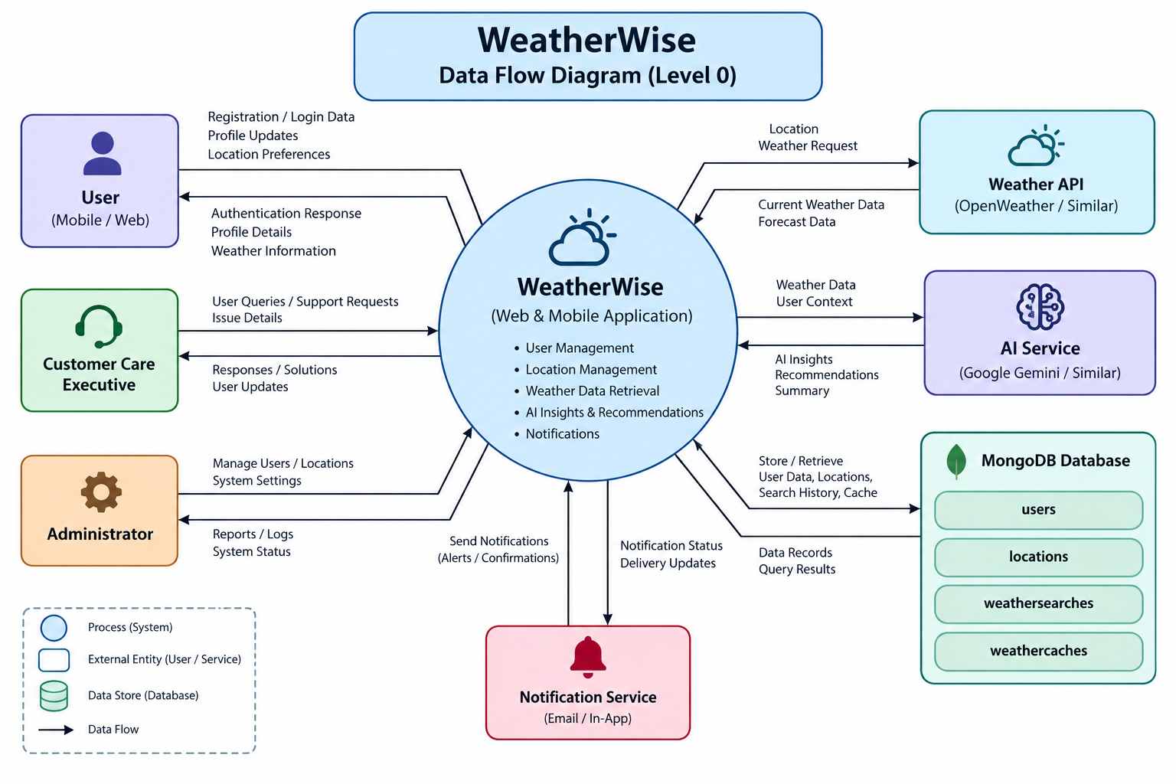

DFD Level 0 – AI WeatherWise:
External Entity | Input / Request | Main Process | Output / Response | Data Store
User | Register / Login  Profile / Favorites | 1.0 User Authentication  & Account Management | Token / Profile /  Authentication status | D1 Users
User | City / Weather request | 2.0 Weather Data  Retrieval & Caching | Current weather data | D2 Weather Cache  D3 Weather Searches
User | Weather details | 3.0 AI Weather Analysis  & Recommendation | AI summary /  Recommendation | D1 Users
User | Favorite location | 4.0 Location Management | Saved locations /  Location list | D4 Locations

Main data flow: User → Authentication / Weather / Location / AI services → MongoDB and external weather service → processed response to User.

System Components:
- User: Registers, logs in, views weather, saves favorite locations, and requests AI-based weather information.
- Authentication Service: Handles registration, login, password protection, and JWT-based access.
- Weather Service: Retrieves current weather information for a requested city and supports caching/search records.
- AI Service: Generates weather summaries and recommendations from weather conditions.
- Location Service: Stores and retrieves users' favorite locations.
- MongoDB: Stores users, locations, weather searches, and weather cache information.
- External Weather API: Supplies current weather data to the WeatherWise backend.

2. User Stories:
The following user stories are prepared for the AI WeatherWise application using the structure in the provided template: User Type, Functional Requirement (Epic), User Story Number, User Story / Task, Acceptance Criteria, Priority, and Release.
User Type | Functional Requirement (Epic) | User Story Number | User Story / Task | Acceptance Criteria | Priority | Release
Customer (Web/Mobile user) | Registration | USN-1 | As a user, I can register for WeatherWise using my name, email, and password. | User account is created successfully and a token is returned. | High | Sprint-1
Customer (Web/Mobile user) | Login | USN-2 | As a user, I can log in using my registered email and password. | Valid credentials authenticate the user and return a JWT token. | High | Sprint-1
Customer (Web/Mobile user) | Profile | USN-3 | As a user, I can view my profile after logging in. | Authenticated user can access profile details with a valid token. | High | Sprint-1
Customer (Web/Mobile user) | Weather Search | USN-4 | As a user, I can search for the current weather of a city. | The requested city returns current weather information. | High | Sprint-1
Customer (Web/Mobile user) | Favorite Locations | USN-5 | As a user, I can add a city as a favorite location. | Authenticated user can save a location with city, country, place, tags, and default status. | High | Sprint-1
Customer (Web/Mobile user) | Favorite Locations | USN-6 | As a user, I can view my saved favorite locations. | The API returns the authenticated user's saved locations. | Medium | Sprint-1
Customer (Web/Mobile user) | AI Weather Summary | USN-7 | As a user, I can request an AI-generated summary of current weather conditions. | The system accepts city, temperature, humidity, and condition and returns an AI summary. | High | Sprint-2
Customer (Web/Mobile user) | AI Recommendation | USN-8 | As a user, I can receive an AI-based recommendation based on weather conditions. | The system returns a recommendation based on temperature and weather condition. | High | Sprint-2
Customer (Web/Mobile user) | Security | USN-9 | As a user, I can access protected services securely. | Requests without a valid authorization token are rejected where authentication is required. | High | Sprint-2
Administrator | System Monitoring | USN-10 | As an administrator, I can monitor whether the WeatherWise API is running. | Health-check endpoint returns API status and timestamp. | Medium | Sprint-2

3. API Endpoints Covered:
Method | Endpoint | Purpose
GET | /api/health | Health check
POST | /api/auth/register | Register user
POST | /api/auth/login | Login user
GET | /api/auth/profile | Get authenticated user profile
POST | /api/locations | Add favorite location
GET | /api/locations | Get favorite locations
GET | /api/weather/:city | Get current weather
POST | /api/ai/weather-summary | Generate AI weather summary
POST | /api/ai/weather-recommendation | Generate AI weather recommendation

4. MongoDB Data Stores:
- users
- locations
- weathersearches
- weathercaches

Note: The DFD and user stories above are adapted to the WeatherWise API requirements provided for this project. The uploaded reference template defines the DFD explanation and the user-story column structure used here.

